Anomalous temperature and seasonality of natural mortality

Overview
As temperature deviates from long-term norms, it will impact deaths from natural causes.^{71,259,260} There is limited analysis on how monthly deviations of temperature from long-term norms will impact natural causes of death, especially in a consistent way across types of death and demographic subgroups of the population. I used data on deaths from natural causes (i.e., all deaths except injuries) and temperature over a 37-year period (1980-2016) in the entire contiguous United States. I formulated a Bayesian spatio-temporal model to estimate how anomalous temperatures affect deaths from a mutually exclusive and collectively exhaustive set of cardiovascular and respiratory diseases as well as cancers, by age group, state and sex. I found that a 1°C anomalously warm year would be associated with an estimated 4,369 (95% credible interval 4,024-4,706) fewer cardiorespiratory deaths in the contiguous United States. The reduction in deaths would mostly be concentrated in 55 years and over, and would occur in all months except for June, July and August, in which deaths would increase. Percentage changes in deaths were similar across states, with the greatest percentage increase in cardiorespiratory deaths in July in New Mexico (1.1%) and Utah (1.2%) for males and females respectively. The greatest reductions in January would be in Louisiana (1.5%) for males and Washington (1.3%) for females. Deaths from cancers show no consistent association with anomalous temperature. The findings indicate that while climate change can and will have many negative effects on society, it will potentially reduce the overall number of deaths in a warmer year.

Introduction
Anthropogenic climate change has the potential to impact health, even in temperate regions of the world. Current assessments of climate change include impacts on cardiorespiratory deaths,^{225,226,233–236} due to well-established associations with changes in temperature.⁸⁸ Cardiorespiratory diseases made up 40% of all deaths in the United States in 2016 and are therefore significant to public health policy and planning (see 3.2.7). While some studies predict some decrease in cardiorespiratory disease deaths due to shifts in temperature under climate change,^{70–72,102} others argue otherwise.^{259,260} As such, understanding of the dynamics of cardiorespiratory disease deaths therefore remains important in public health research and policy. Deaths from cancers make up a significant proportion of deaths in the United States and it is therefore important to understand an association between cancer mortality and temperature. More evidence is required about how changes in cardiorespiratory deaths will be distributed by type of cardiovascular and respiratory disease, age group, sex and month of the year.²⁵⁹
There has also been limited analysis on the potential association between deaths from cancers and anomalous temperature. Our aim was to evaluate how deaths from various chronic diseases, including deaths from cardiorespiratory disease and cancer, may be affected by changes in temperature that could arise as a result of global climate change in a national study.

Data
Full details of the data processing choices I made can be found in Chapter 3. Here, I used vital registration data on all 79,689,529 natural (i.e., non-injury) deaths in the contiguous United States from 1980 to 2016 along with population records to calculate monthly death rates for each type of cardiorespiratory disease as well as cancers and other deaths, age group, sex and state combination. Of this, 41,105,009 were deaths from cardiorespiratory diseases, 19,862,760 were deaths from cancers, and 18,721,760 deaths were from causes other than cancers, cardiorespiratory diseases and injuries.
For each cardiorespiratory death, I mapped each ICD-9 and ICD-10 code to three cardiovascular (ischaemic heart disease, cerebrovascular disease, other cardiovascular diseases) and three respiratory (chronic obstructive pulmonary disease (COPD), respiratory infections, other respiratory infections) types of cardiorespiratory deaths (Table 11). Other cardiovascular diseases included rheumatic, hypertensive and inflammatory heart diseases. Other respiratory diseases, within each respectively the type of cardiovascular and respiratory disease that led to death varied by sex and age group. Causes of cardiorespiratory deaths within these groups include asthma and otitis media (Table 11). I did not further subdivide cancer deaths (Table 11). I obtained monthly population-weighted temperature from ERA-Interim.²⁰³

Chronic disease | ICD-9 | ICD-10
Cardiorespiratory | 381-382, 390-519 | H65-H66, I00-J99
Cardiovascular diseases | 390-459 | I00-I99
Ischaemic heart disease | 410-414 | I20-I25
Cerebrovascular disease | 430-438 | I60-I69
Other cardiovascular diseases | 390-409, 415-429, 439-459 | I00-I19, I26-I59, I70-I99
Respiratory diseases | 381-382, 460-519 | H65-H66, J00-J99
COPD | 490-492, 495-496 | J40-J44
Respiratory infections | 381-382, 460-466, 480-487 | J00-J6, J9-J18, J20-J22
Other respiratory diseases | 467-479, 488-489, 493-494, 497-519 | H65-H66, J7-J8, J19, J23-J39, J45-J99
Cancers | 140-239 | C00-C99, D00-D48
Table 11. Chronic disease groups used in the analysis with ICD-9 and ICD-10 codes.

Statistical methods
I then analysed the association of monthly cardiorespiratory death rates with anomalous temperature using a Bayesian spatio-temporal model, described fully in Chapter 5. The model accounted for systematic variations in death rates across states and months, through state-, month- and state-month-specific random intercepts, and for their long-term trends. These terms together remove the effects of space and time varying factors other than temperature that affect injuries. Analyses were done separately by cardiorespiratory disease type, sex and age group. I used the resultant risk estimates and the age-sex-specific death rates from each cardiorespiratory disease type in 2016, to calculate additional deaths if each month in each state were +1°C above its long-term norm, by type of cardiorespiratory disease, sex, age group, state and month.
For each type of cardiorespiratory disease and cancer death, I calculated summaries of proportional changes in death by age and sex for all months (Figure 48) and by month for all ages (Figure 49) using 5000 posterior draws from the marginal of each month’s excess relative risk. My model design, detailed in in Chapter 5, produced an excess risk for each combination of cardiorespiratory disease or cancer death, month, age groups and sex (Figure 50-Figure 57). I found no association between proportional change in deaths from cancers (Figure 57). I therefore did not include the results in further calculations.
I also ran a model where each state was given a separate temperature anomaly coefficient (Equation 9 in Chapter 5), In this model, I used all cardiorespiratory diseases together as my dataset.
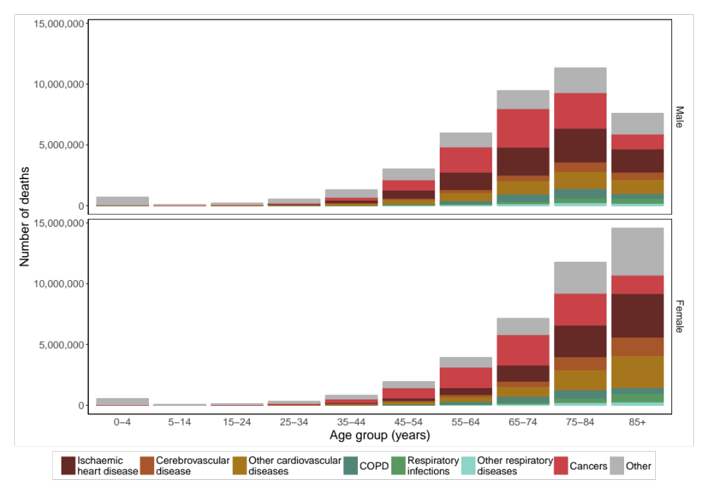
Figure 44. Number of deaths by natural cause, sex and age group in the contiguous United States for 1980-2016.

Results
20,070,797 boys and men and 21,034,212 girls and women died from cardiorespiratory diseases in the contiguous United States during 1980 to 2016. This accounted for 46.3% and 49.9% of all male and female deaths respectively (Figure 2 in Chapter 3). 77.1% of male cardiorespiratory disease deaths and 88.7% of female cardiorespiratory disease deaths were in those aged 65 years and over (Figure 44). For females, 42.7% of female cardiorespiratory disease deaths were in those aged 85 years and over (Figure 44).
Deaths from ischaemic heart disease accounted for 45.3% of cardiorespiratory disease deaths in males and 38.7% in females (Figure 44). Males 25 years and above and females 35 years and above died from ischaemic heart disease more than any other cardiorespiratory disease. The largest single proportion of ischaemic disease as a proportion of total cardiorespiratory deaths was in 45 to 54 year old men (52.1%). Below 25 years of age, respiratory infections were the largest single cause of cardiorespiratory disease death in both males and females.
As previously demonstrated in Chapter 4, there has been a constant seasonality over time in cardiorespiratory deaths for most age groups in both sexes (Figure 17 and Figure 18). For each of the six types of cardiorespiratory disease death, there were more deaths in the winter than in the summer when added up over the entire period of study (Figure 45).
There was a decline in age-standardised death rates of four out of six major types of cardiorespiratory disease (ischaemic heart disease, cerebrovascular disease and respiratory infections) for both men and women from 1980 to 2016. The largest and most dramatic overall decline over time was for ischaemic heart disease deaths, which declined by over 50% for both men and women from 1980 to 2016 (Figure 46), driving the overall reduction in cardiorespiratory deaths (Figure 2 in Chapter 3). COPD deaths in males, while increasing from the 1980s until the late 1990s, have steadily decreased since then. The male age-standardised death rate for COPD contrasts with those of females, which have been steadily increasing since the 1980s (Figure 46). Other respiratory disease age-standardised death rates also increased over the time period. There is a jump downwards in age-standardised death rates in other cardiovascular diseases due to the change from the ICD-9 to ICD-10 coding which occurred in 1999, when more causes of death from the grouping were assigned to ischaemic heart disease (Figure 46). Age-standardised death rates for all cardiorespiratory diseases were highest in winter, which was highlighted in most age groups and both sexes in my study of the dynamics of seasonality in Chapter 4.²⁸
In cancers, 10,428,202 boys and men and 9,434,558 girls and women died in the contiguous United States, accounting for 24.0% and 22.4% of all male and female deaths respectively (Figure 2 in Chapter 3). There were slightly more deaths from cancer overall in the winter than in the summer, and XX% of deaths were from those aged 55 and over (Figure 45). Seasonality in cancer deaths was also evident in those 55 years and older (Figure 15 and Figure 16 in Chapter 4). Deaths from cancers accounted for 21.3% and 21.2% of total deaths in 1980, and 23.1% and 21.6% of total deaths in 2016, for males and females respectively, peaking in proportion of total deaths for males in the 1990s and 2000s then returning back to a lower value. Over time, death rates from cancers have decreased overall (Figure 46). The remainder of deaths were from causes other than cancers, cardiorespiratory diseases and injuries. Causes of death in this grouping included infectious and parasitic diseases; endocrine diseases, nutritional and metabolic diseases; immunity disorders; mental disorders; diseases of the nervous system; diseases of the digestive system; diseases of the genitourinary system; complications with pregnancy; skin diseases; diseases of the musculoskeletal system and connective tissue; and congenital anomalies. The composition of this group of causes of death varied by age group and sex. Therefore, I did not include the results in further calculations.
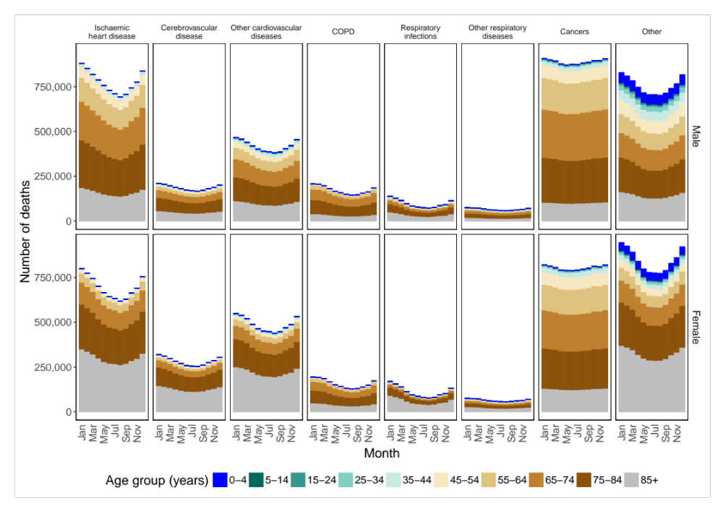
Figure 45. Number of deaths by natural cause, month, sex and age group in the contiguous United States for 1980-2016.
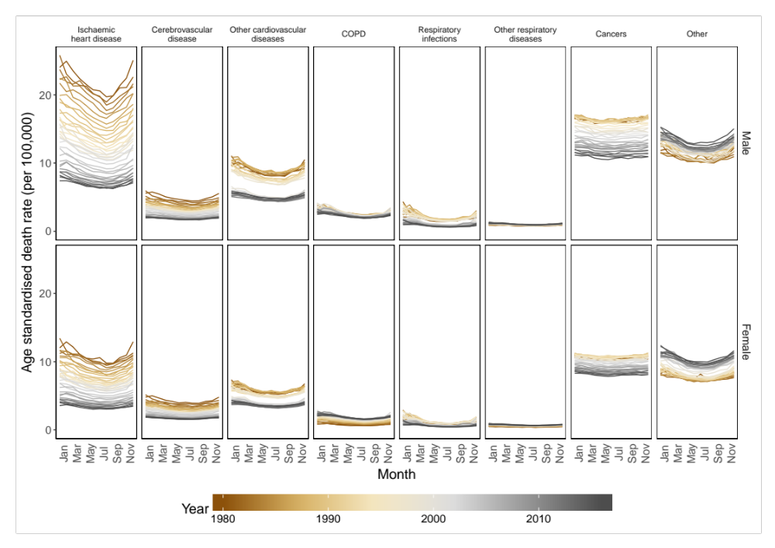
Figure 46. National age-standardised death rates from 1980 to 2016, by sex, cardiorespiratory disease and month

I estimated that there would be 4,369 (4,024, 4,706) fewer cardiorespiratory disease deaths, equivalent to 0.4% of all cardiorespiratory deaths in 2016, in a year in which each month in each state were +1°C above its long-term norm (Figure 47). Deaths from all types of cardiovascular disease (ischaemic heart disease, cerebrovascular disease and other cardiovascular diseases) and respiratory disease (COPD, respiratory infections and other respiratory diseases) would be predicted to increase (Figure 47). The biggest reduction of deaths would be from ischaemic heart disease (1,883 (1,706, 2,058)) followed by other cardiovascular diseases (1,039 (835, 1,243)). 55% of the reduction in deaths would occur in males and 45% in females. Across months, there would be decreases in all months across all cardiorespiratory diseases, with the exception of the summer months (June, July and August), where there would be the greatest single increase in July for other cardiovascular diseases for both males (76 (41, 112)) and females (103 (62, 144)). The biggest reductions by month would occur in the coldest months (November, December, January and February) (Figure 47). 81% of the total reduction in deaths would be from cardiovascular disease deaths, with the rest in respiratory diseases (Figure 47). 4,236 deaths (97%) of overall reduction would come from those aged 55 years and over.
Proportionally, deaths from ischaemic heart disease are predicted to decrease most consistently, for older ages than other cardiorespiratory diseases, with proportional changes in deaths for those 55 years greater than 0.5% in males and 0.2% in females (Figure 48). Younger age groups generally possess a large range of uncertainty in all types of cardiorespiratory disease death due to the small numbers of deaths (Figure 48). The largest single decrease was that of respiratory infections in males 85 and over, (1.0% (0.7%, 1.3%)) (Figure 48). The scale of the percent changes were similar in both males and females across ages and cardiorespiratory diseases (Figure 48).
There were variations in association between proportional change in deaths for all ages combined across months (Figure 49). In comparison to percent change in injury deaths (Figure 37 in Chapter 6), there was a general pattern of largest decrease in the winter months combined with either lower decreases or increases in the summer (Figure 49). The main exceptions were for COPD in females and other respiratory diseases in both sexes (Figure 49), though low absolute numbers of other respiratory disease deaths led to the large uncertainty in the values (Figure 49). The largest single increase was for other cardiorespiratory diseases for females in July (0.7% (0.4%,1.0%), with the largest single decrease for ischaemic heart disease for males in December (1.1% (0.9%, 1.2%). (Figure 49).

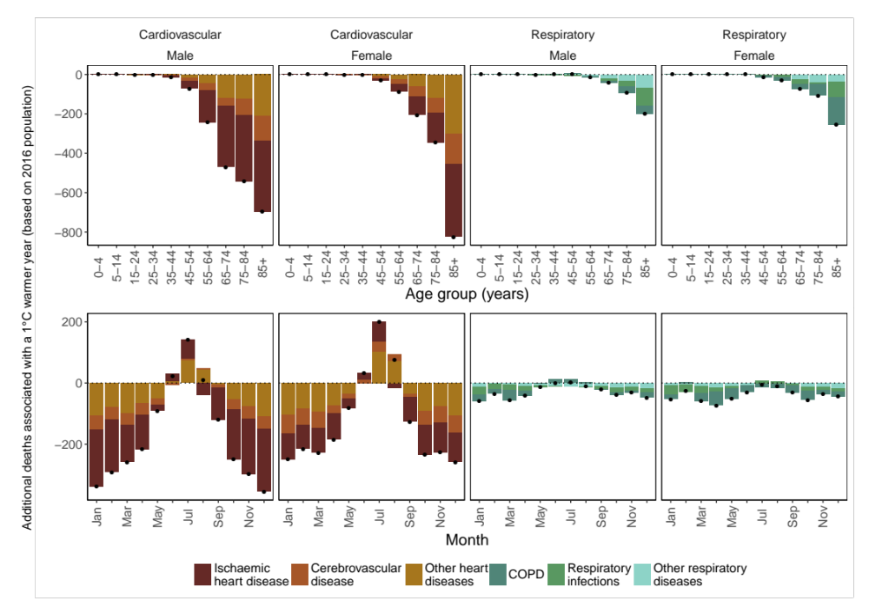
Figure 47. Additional annual cardiorespiratory disease deaths for the 2016 US population in year in which each month was +1°C compared with 1980-2009 norm temperatures. The top row shows breakdown by type of cardiorespiratory disease, sex and age group. The bottom row shows the break down by cardiorespiratory disease, sex and month. Black dots represent net changes in deaths for each set of bars.

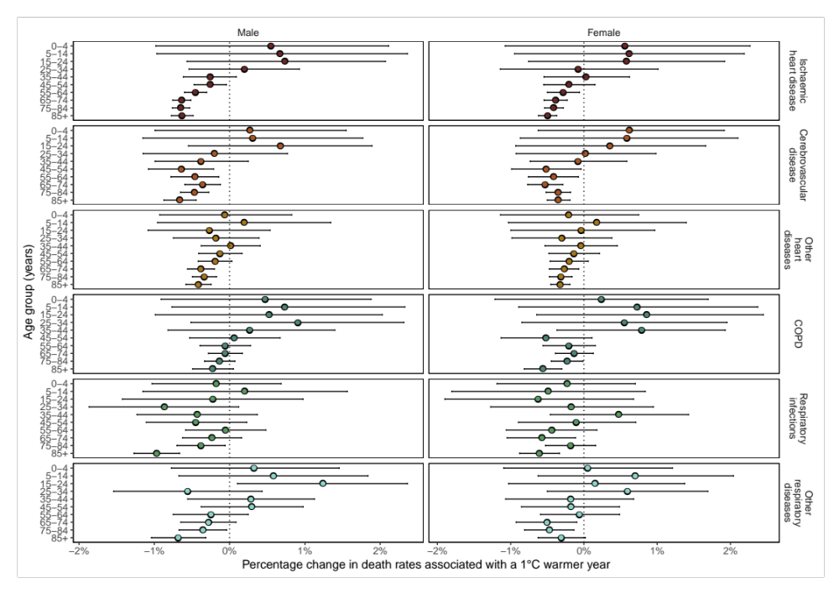
Figure 48. Percent change in death rates in year in which each month was +1°C compared with 1980-2009 norm temperatures by cardiorespiratory disease, sex and age group summarised across months.

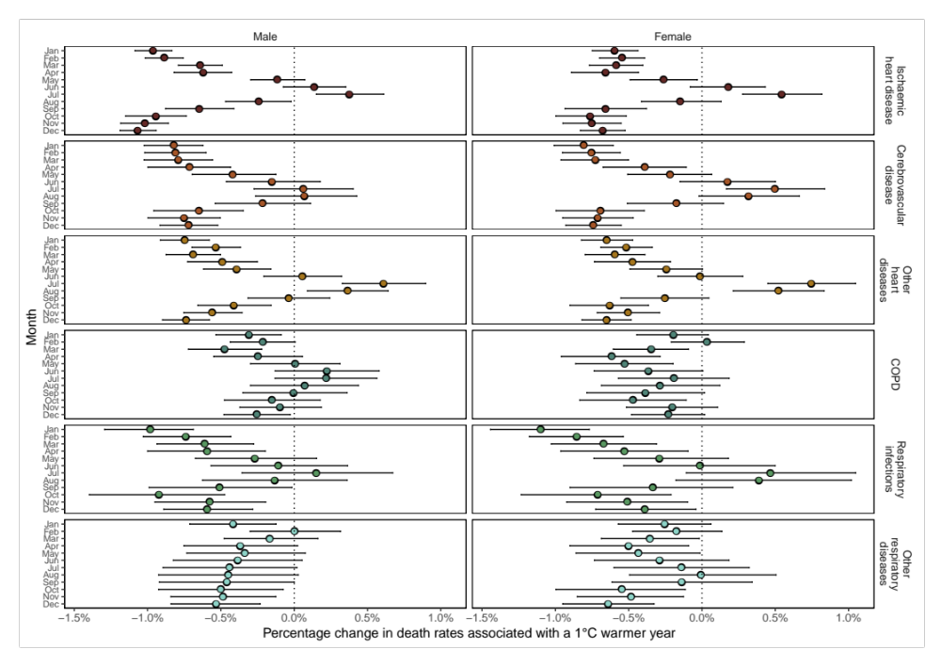
Figure 49. Percent change in death rates in year in which each month was +1°C compared with 1980-2009 norm temperatures by cardiorespiratory disease, sex and month summarised across age.


Figure 50. Excess relative risk in ischaemic heart disease death rates in year in which each month was +1°C compared with 1980-2009 norm temperatures by month, sex and age group.

Figure 51. Excess relative risk in cerebrovascular disease death rates in year in which each month was +1°C compared with 1980-2009 norm temperatures by month, sex and age group.

Figure 52. Excess relative risk in other cardiovascular disease death rates in year in which each month was +1°C compared with 1980-2009 norm temperatures by month, sex and age group.

Figure 54. Excess relative risk in COPD death rates in year in which each month was +1°C compared with 1980-2009 norm temperatures by month, sex and age group.

Figure 55. Excess relative risk in respiratory infection death rates in year in which each month was +1°C compared with 1980-2009 norm temperatures by month, sex and age group.

Figure 56. Excess relative risk in other respiratory disease death rates in year in which each month was +1°C compared with 1980-2009 norm temperatures by month, sex and age group.

Figure 57. Excess relative risk in cancer death rates in year in which each month was +1°C compared with 1980-2009 norm temperatures by month, sex and age group.
Within each month, percentage change in deaths by state is largely similar across the United States (Figure 60 and Figure 61). January, which is an illustrative month for the impacts of anomalous temperature in winter months, exhibits a decrease across the map with a decrease in range -1.5% (-1.2%, -1.9%) (Louisiana) to -0.2% (-0.1%, -0.4%) (New Mexico) in males (Figure 60), and -1.3% (-1.0%, -1.7%) (Washington) to -0.1% (-0.5%, 0.3%) (Arizona) in females (Figure 61). July, which is an illustrative month for the impact of anomalous temperature in summer months, exhibits an increase in 47 out of the 49 contiguous states (including District of Columbia) for males (Figure 60) and all states for females (Figure 61). The biggest increase in July for males is in New Mexico, at 1.1% (0.5%, 1.7%) (Figure 60) and in Utah, at 1.2% (0.6%, 1.7%) for females (Figure 61). The months between January and July exhibit more difference between states, though broadly consistent with national monthly patterns from the majority of cardiorespiratory disease death in Figure 49. The number of total reduction in deaths predicted by the sub-national model is more than the national model (Figure 62).

Figure 60. Percent change in death rates for males in year in which each month was +1°C compared with 1980-2009 norm temperatures for all cardiorespiratory diseases by state and month summarised across age groups.

Figure 61. Percent change in death rates for females in year in which each month was +1°C compared with 1980-2009 norm temperatures for all cardiorespiratory diseases by state and month summarised across age groups.
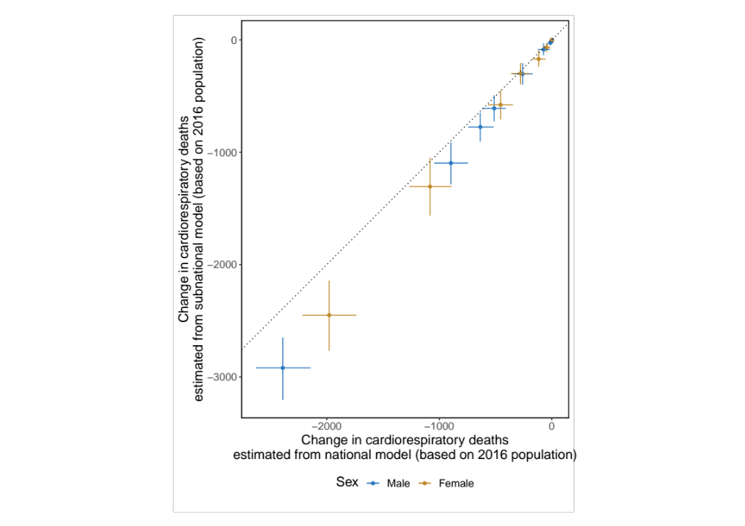
Figure 62. Comparison of additional annual cardiorespiratory disease deaths for the 2016 US population in year in which each month was +1°C compared with 1980-2009 norm temperatures, from national model (Equation XX) by cause of death (x-axis) against subnational model (Equation XX) of all cardiorespiratory deaths (y-axis).

Discussion
- How well do results agree with previous ones?
- Paragraph for each of the 4 causes
- Major strengths of study?
- Why work is important?
- What to say about reduction in context of climate change still being bad?

Summary

The contents of this chapter are in a paper which is currently being prepared for submission.

